**Hands-on .NetCore 3.0**

**Handling User Input**

Table of Contents

Scaffolding Console App Basics 2

Handling User Input Console 2

Creating the console app 2

Program.cs 2

# Scaffolding Console App Basics

We have already run the commands multiple times, here is the info

* dotnet new console
* dotnet restore [pulls in the dependencies needed by the application]
* dotnet run [compiles and run the application]
* dotnet build [compiles the application]
* dotnet publish [packages up the files for reuse]

Take a look at this document for more details:

<https://itplate.blogspot.com/2019/11/scaffolding-applications-with-net-cli.html>

# Handling User Input Console

## Creating the console app

Run command **dotnet new console -o HandlingUserInput**

It has done the restore for us as well

Open the app with VS Code by

1. **cd HandlingUserInput**
2. and then typing **code .** [code space dot]

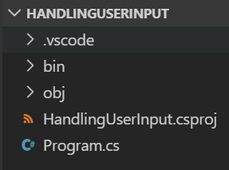

## Program.cs

We’ll be using **Console.ReadLine** to read the user input. Also, there are two example

1. User input will be asked on a new line
2. User input will be asked on the same line

Also using different colors to display the info. Check the project built under 04-DifferentColorTextConsole for more details.

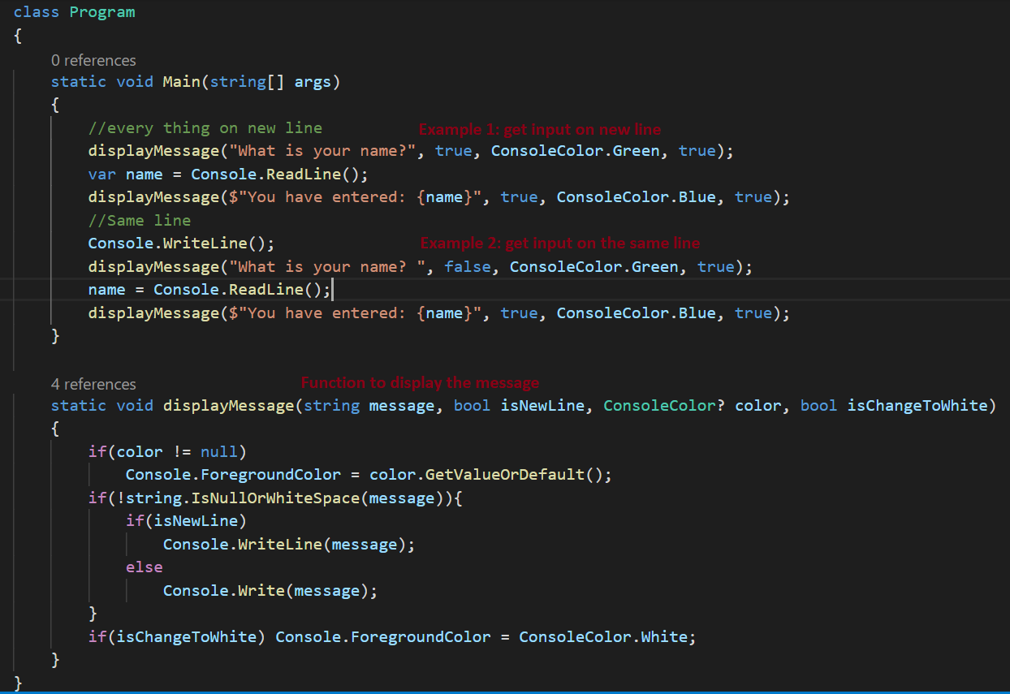

Run the console app using command **dotnet run**, the output will show as

